How to Run:

Unzip the File **dist.zip**

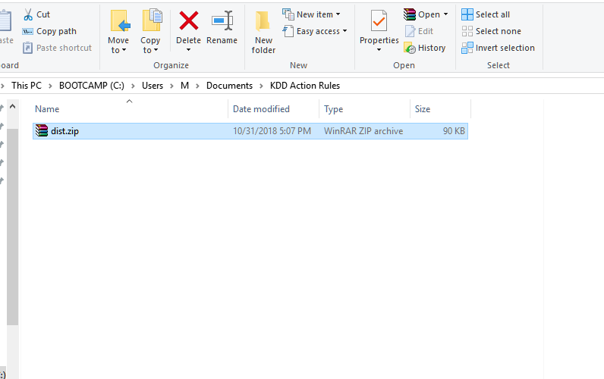

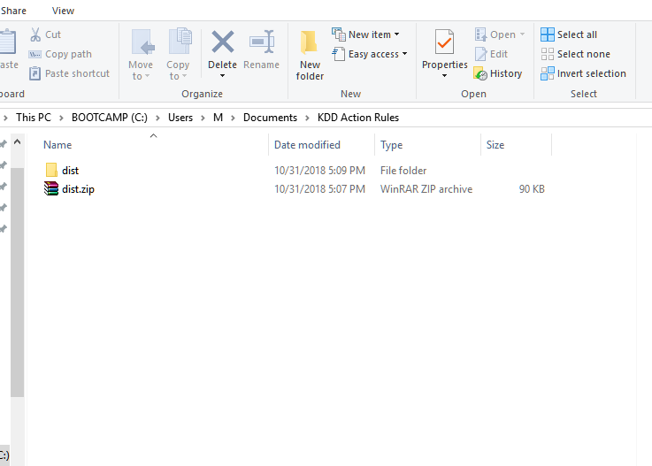

Open folder “dist”

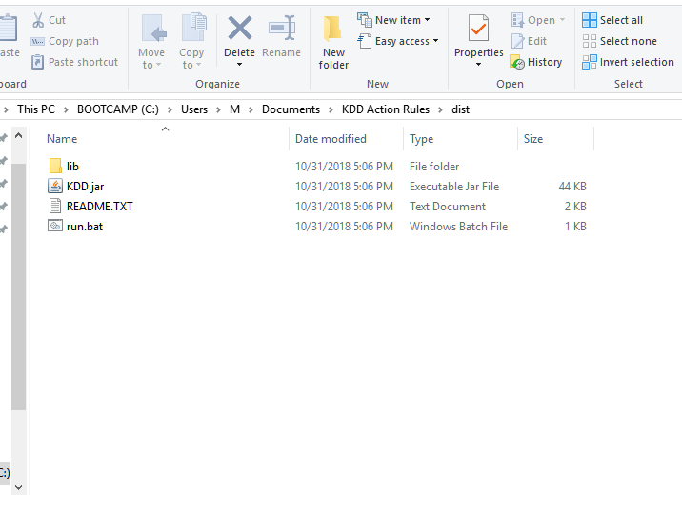

Run “Run.bat”

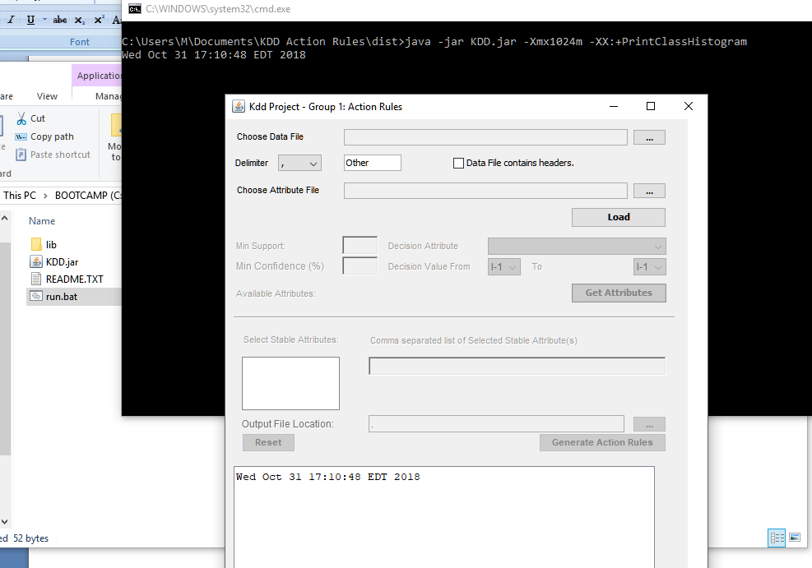

Choose a data file

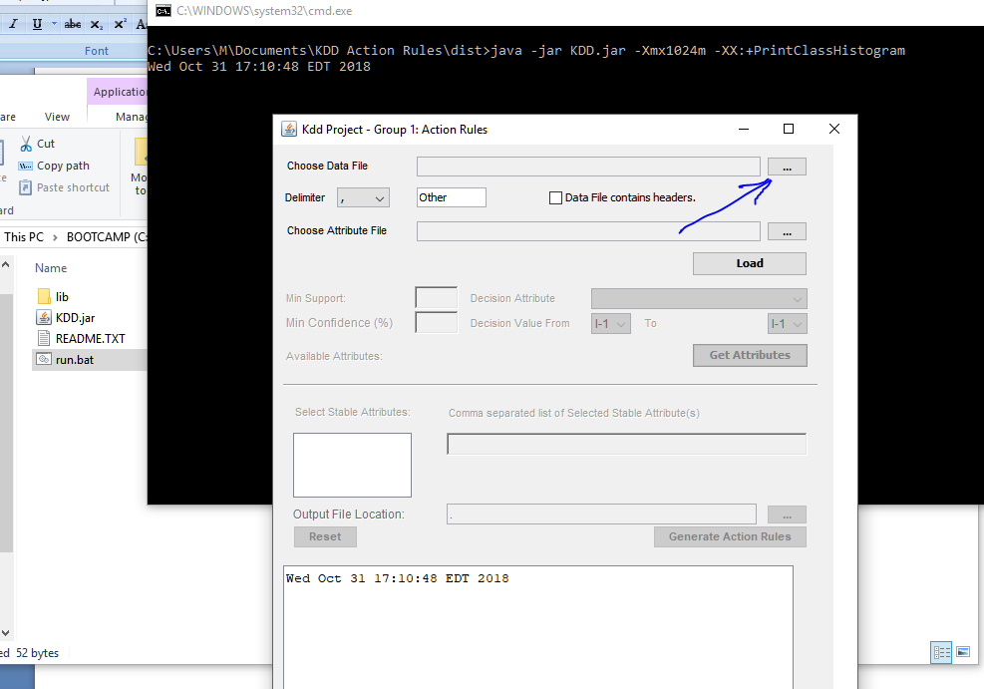

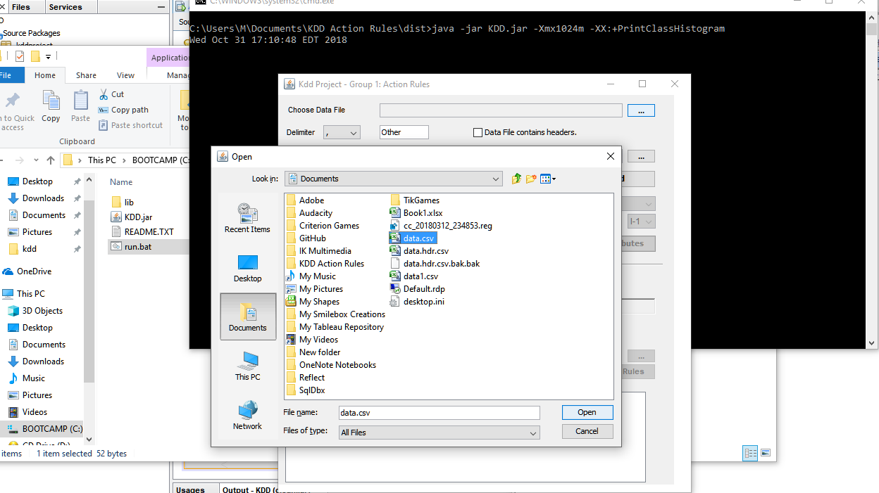

You should be able to see the path of the data file

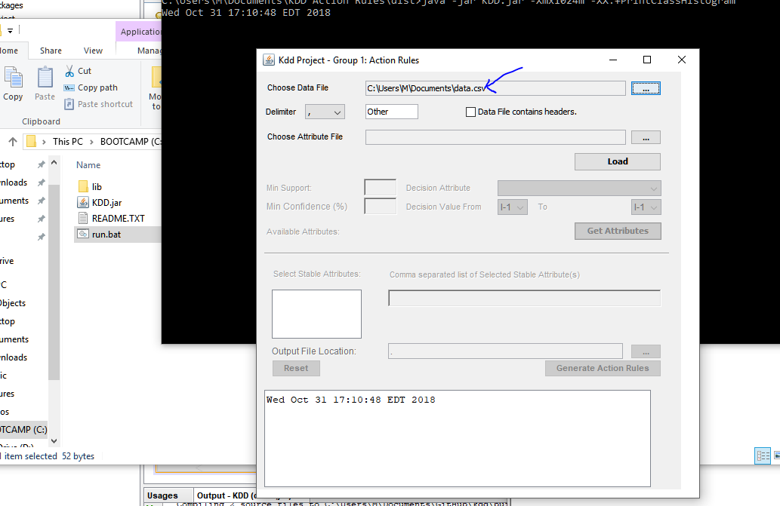

Choose Delimiter:

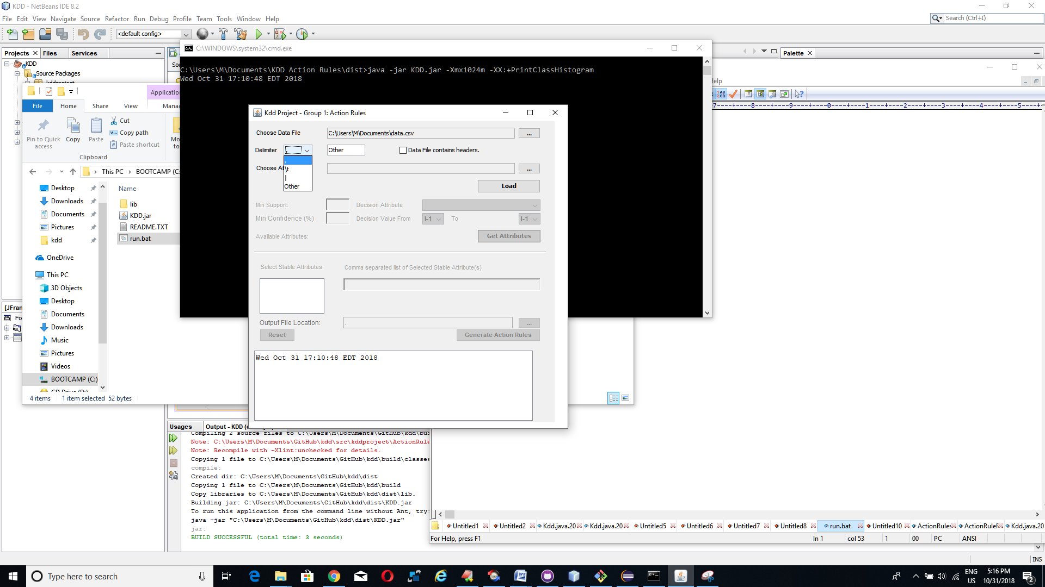

Check “Data File contains headers” if the first record in your data has the attribute names:

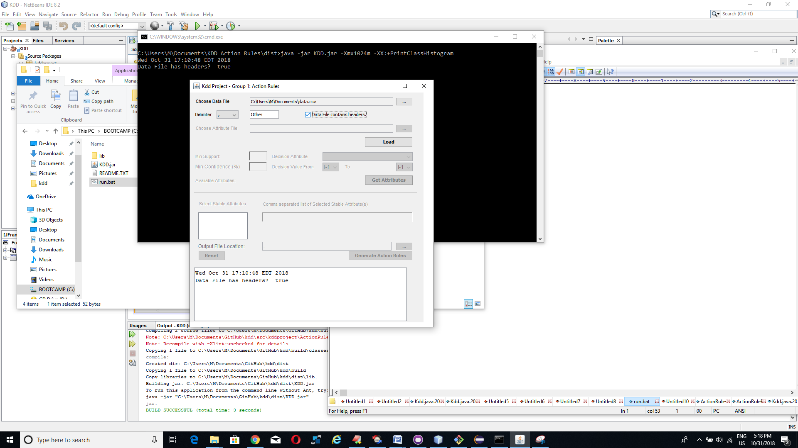

This will disable the attribute file selection

If you wish to use another file as the attribute file you can do so by unchecking “Data File contains headers” and then choosing the attribute file:

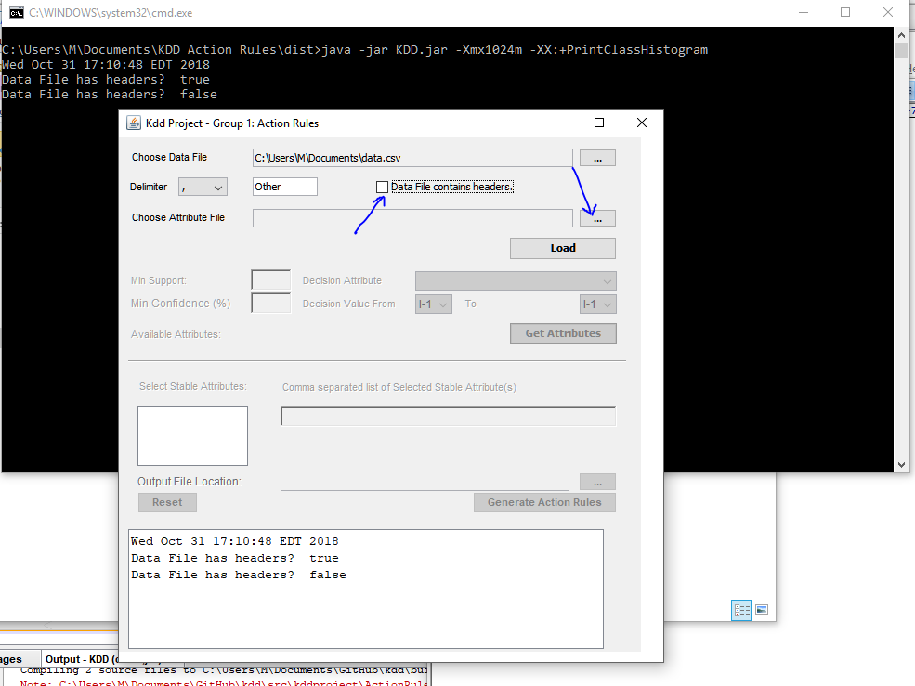

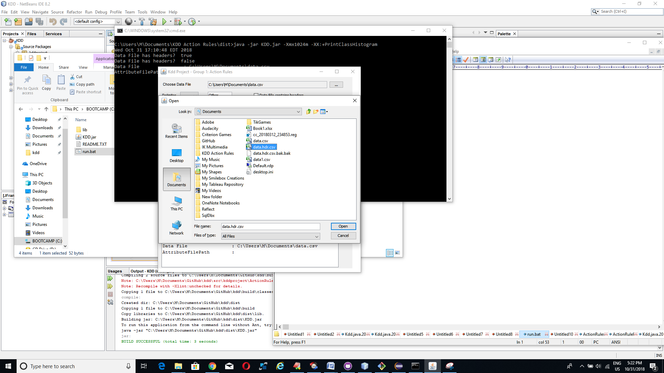

You should be able to see the path of the attribute file

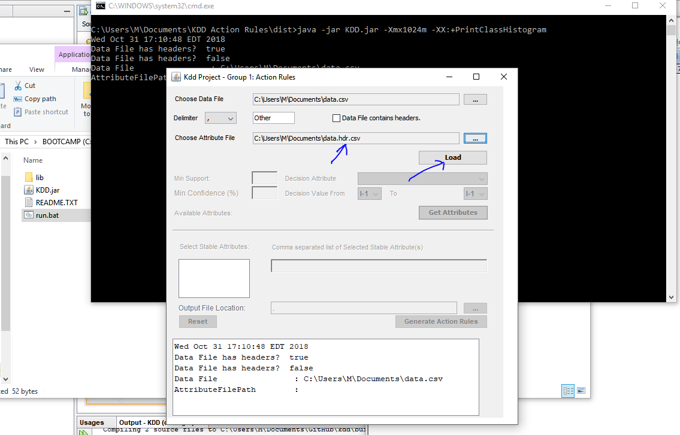

Now Click on **Load.** You should be able to see the list of all the attributes in the Decision Attribute Dropdown.

Enter the following :

1. Minimum Support
2. Minimum Confidence %

And choose the following:

1. Decision Attribute
2. Decision Attribute From
3. Decision Attribute To

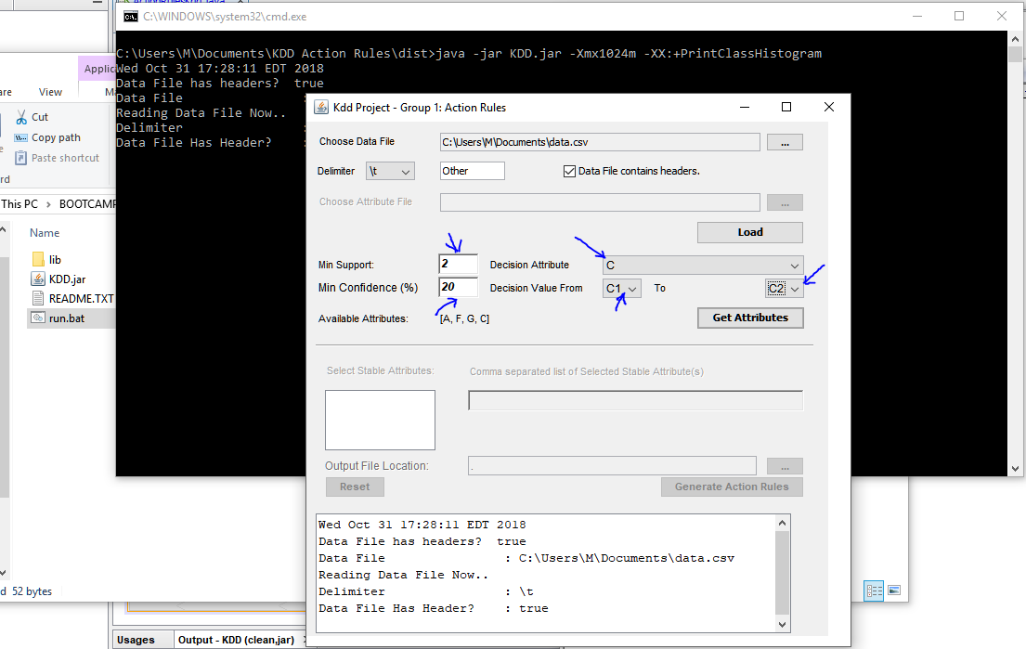

Now Click on “Get Attributes”. This will make the stable attributes available for selection. Multiple attributes can be selected as stable attributes using Ctrl + Click on stable attribute name:

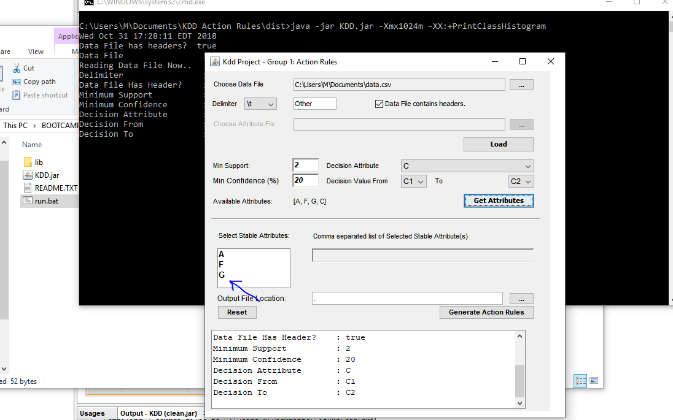

The selected attributes are displayed in the text box and are separated by commas

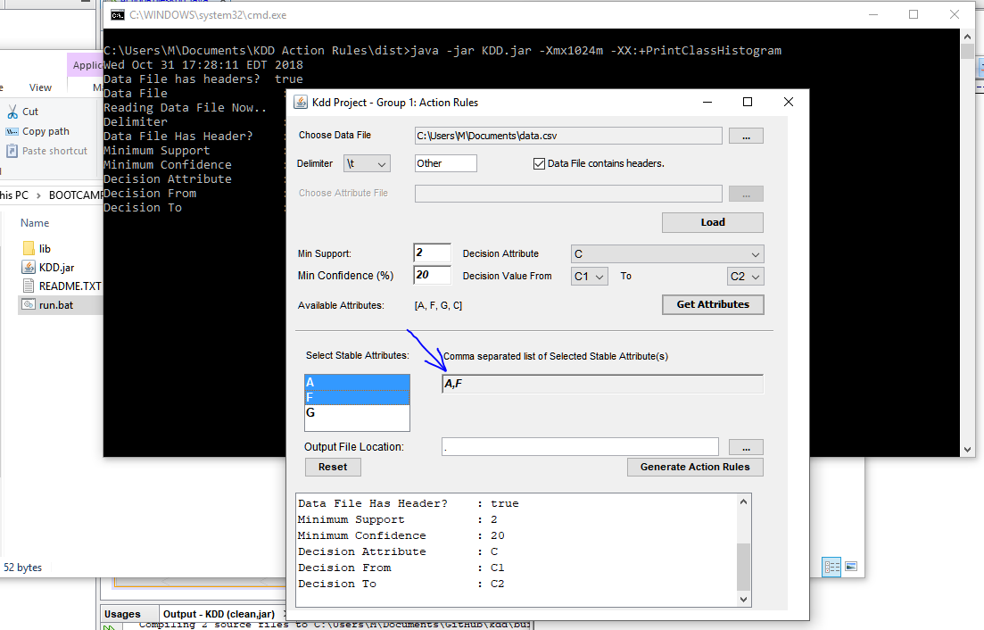

Now click on The Output directory selection button choose a folder where you want the output of the program to be saved

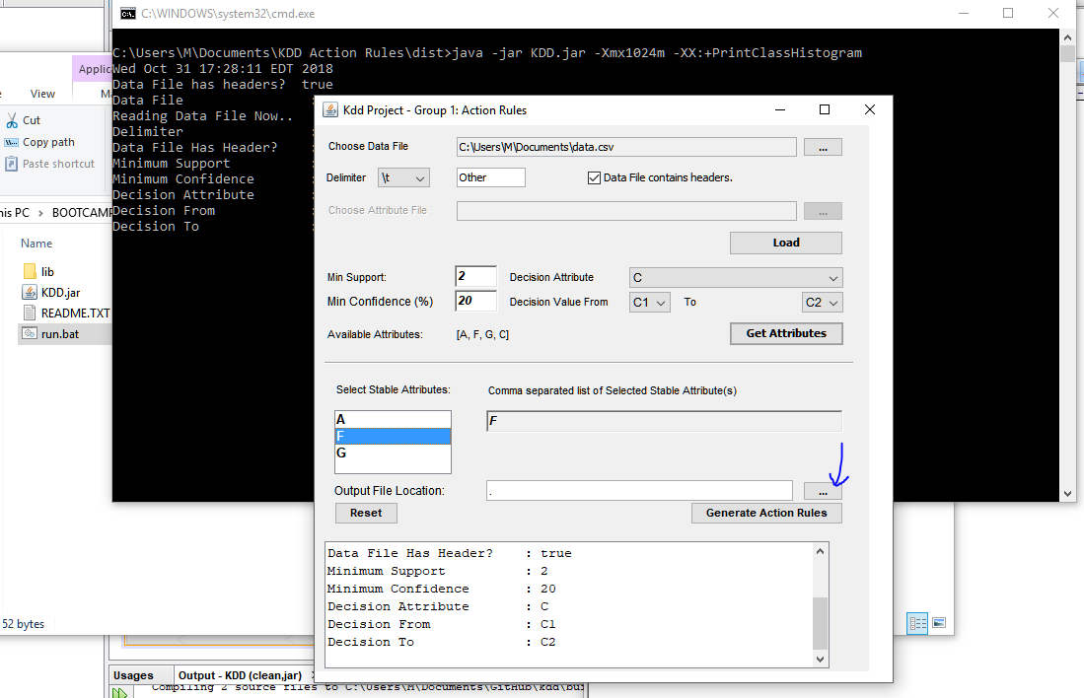

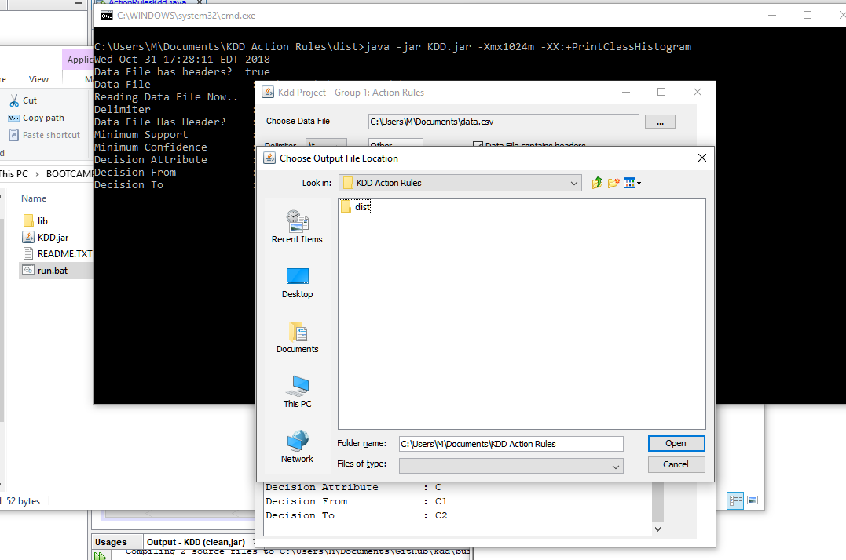

You should be able to see the path of the output location:

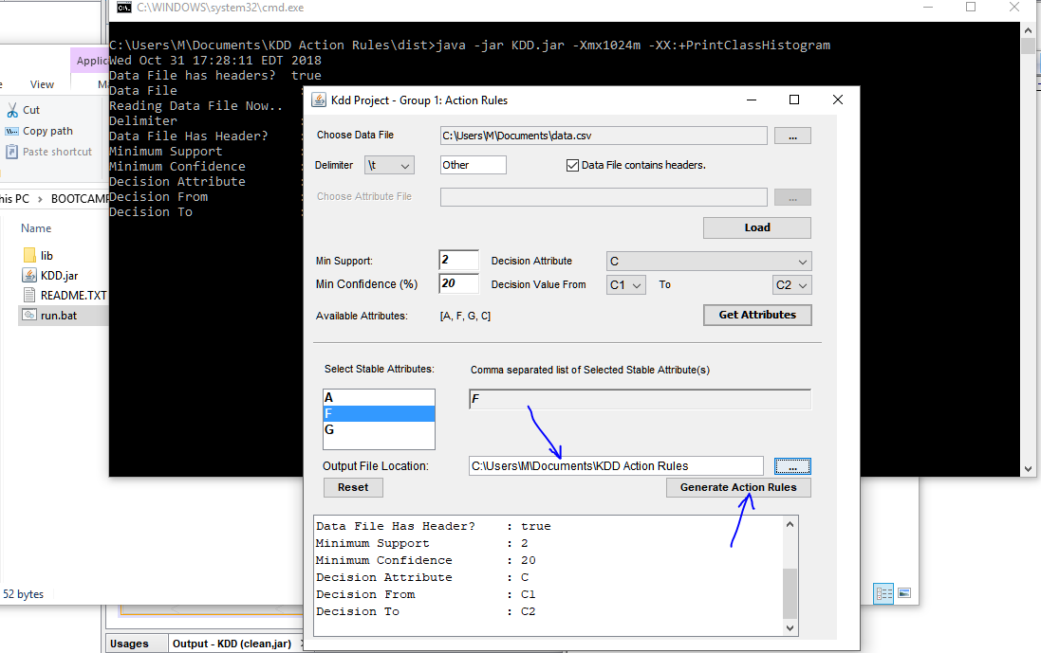

Now click on Generate Rules:

Output of the program will be visible in the console and the text area:

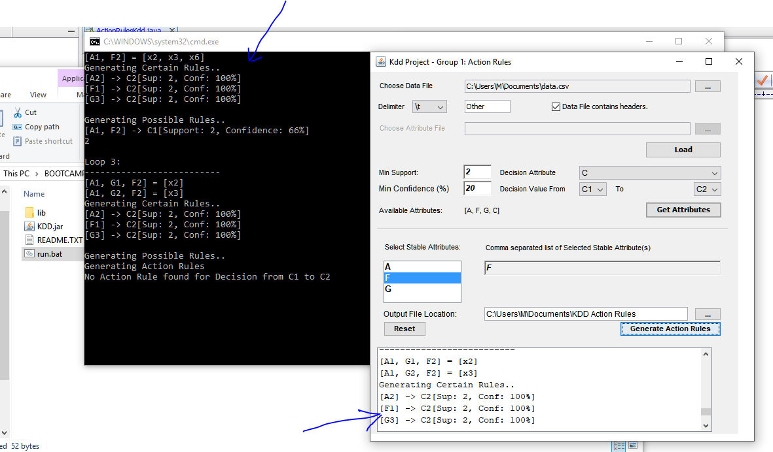

The output will also be available in the output folder selected:

